Setting up a database in the Raspberry Pi

1. Install sqlite on Raspberry Pi – sudo apt-get install sqlite
2. Create a database called ‘TemperatureData’ 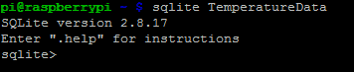
3. Create a table layout for that Database



1. Import data